Title:

AI-Based Loan Assessment System for Farmers Using 20 Years of Crop Data

# Problem Description

Farmers, particularly smallholders, face challenges in securing loans due to fluctuating incomes and lack of collateral. Traditional banking systems often fail to account for agricultural risks, forcing farmers to rely on high-interest money lenders.

# Key Pain Points:

* **Limited Credit Access:** 70% of rural farmers are underbanked due to unstable incomes and lack of collateral (World Bank).
* **Volatile Crop Yields:** Agricultural yields are unpredictable, affected by weather, pests, and market fluctuations.
* **High Loan Defaults:** Agricultural loan defaults range from 30-40%, driven by poor risk assessments.
* **Underutilization of Data:** Existing financial systems ignore dynamic data like past crop yields and market trends, leading to inaccurate loan decisions.

# Key Statistics:

* 85% of small farmers struggle to access formal credit.
* Agriculture contributes 15-20% to GDP, yet less than 50% of farmers have institutional credit access.

# Problem Validation Field Studies:

Farmers, like those in Tekkali, struggle with loan approval due to fluctuating crop yields and market prices, making it difficult to meet bank requirements.

# Banking Data Validation:

Historical banking data shows that loans are often assessed using outdated models, leading to high loan defaults when market and environmental risks are overlooked.

# Existing Solutions and Their Limitations

1. **Traditional Banking Systems:**
   * **Limitation:** Rely on static financial data, ignoring weather and market risks, often resulting in either loan rejections or granting loans to high-risk farmers.

# Government Loan Schemes:

* + **Limitation:** Often lack detailed risk assessments, leading to misallocation of loans and high defaults.

# Agri-Tech Solutions (e.g., Cropin’s Smart Risk):

* + **Limitation:** Require advanced tech integration, often inaccessible to small banks or rural areas with low technological infrastructure.

# Your Solution: AI-Based Loan Assessment System Overview:

An AI-powered system that uses 20 years of crop data to assess loan eligibility for farmers, considering dynamic factors like weather, market fluctuations, and historical crop performance to minimize loan defaults.

# Key Features:

1. **Predictive Modelling:** Utilizes machine learning models (e.g., ARIMA, LSTM) to predict future crop yields and market trends.
2. **Dynamic Risk Assessment:** Integrates external factors (weather, political events) and crop performance to assign a risk score.
3. **Tailored Loan Recommendations:** Recommends loan amounts based on the risk score, with flexible interest rates to reduce bank risk.

# Uniqueness:

* + **AI-Driven Predictions:** Forecasts crop performance using historical data.
  + **Inclusion of External Factors:** Considers climate, market, and geopolitical events for accurate risk assessments.
  + **Scalable for Rural Banks:** Designed for deployment in regions with minimal tech infrastructure, making it accessible to smaller banks.

# Technical Description & Feasibility

1. **Data Collection:**
   * Uses 20 years of crop data (e.g., cotton, chilli, paddy, tamarind) and integrates external datasets (weather, market prices).

# Machine Learning Models:

* + **Time Series Forecasting:** ARIMA/LSTM to predict future crop yields.
  + **Regression Models:** Linear and polynomial regression to assess crop performance.
  + **Classification Models:** Logistic Regression and Random Forest for loan eligibility scoring.

# Risk Scoring Algorithm:

* + Combines crop yield predictions, external risks, and historical performance to generate a risk score, determining loan amounts and interest rates.

# Feasibility:

* **Data Availability:** 20 years of historical data ensures the model is well-trained and reliable.
* **Technical Tools:** Python, scikit-learn, and statsmodels allow easy integration into banking infrastructure.
* **Cost Efficiency:** Automates risk assessments, reducing defaults and boosting bank profitability.

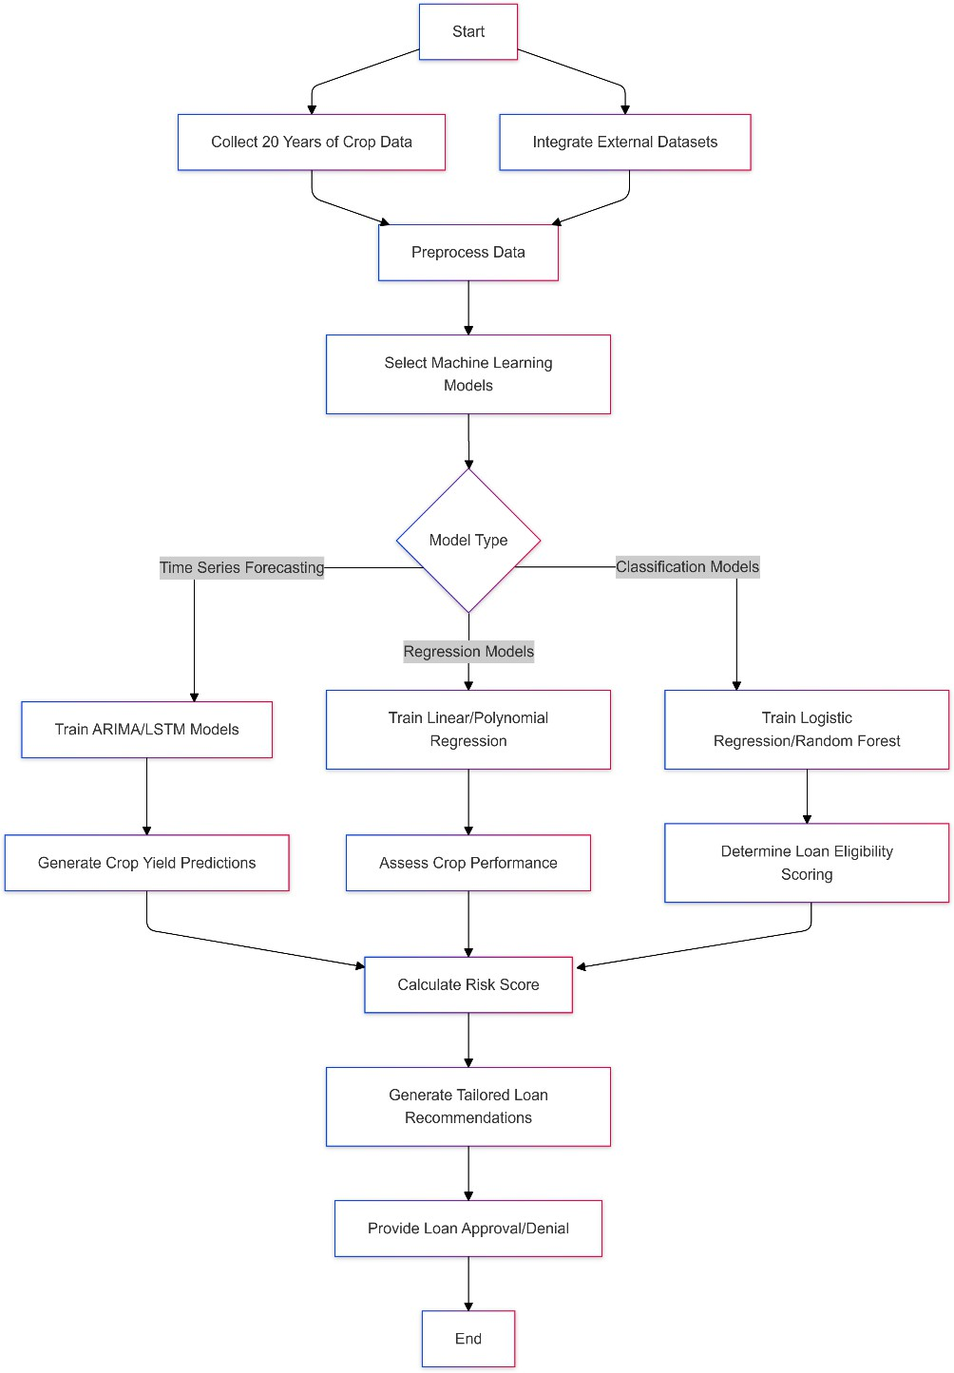**flowchart:**

**Prototype Image:**

